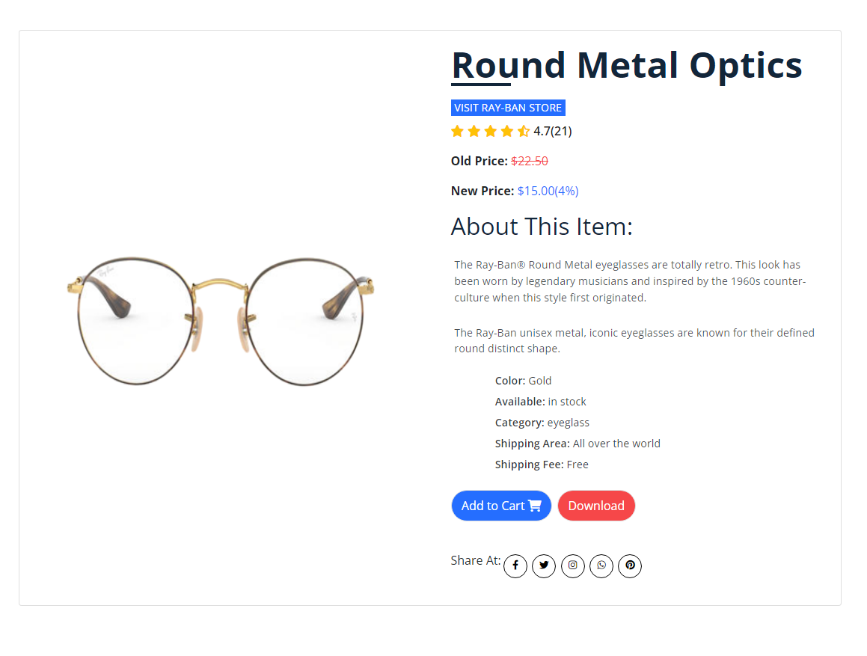
The Ray-Ban® Round Metal eyeglasses are totally retro. This look has been worn by legendary musicians and inspired by the 1960s counter-culture when this style first originated. The Ray-Ban unisex metal, iconic eyeglasses are known for their defined round distinct shape. A curved brow bar, adjustable nose pads, and thin metal temples with plastic end tips rest comfortably behind the ears.
Product Details

